2024 Summer Reading Story Time Registration Form

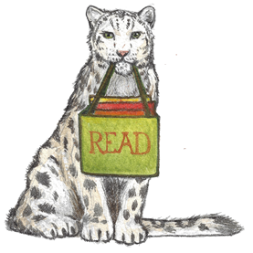

Name:_________________________________________

Address:_______________________________________

Phone: ________________________________________

Parent Email:__________________________________

Age: ______ (Must be accompanied)

I give permission for the Summer Reading Program Directors to photograph my child for the purpose of promoting the summer reading program.

YES_____ or NO______

**Parental** **Signature (Required): ______________________________________**

**________________________________________________________________**

For library use only: Programs attended: 1 2 3 4 5 6 7 8

2024 Summer Reading Story Time Registration Form



Name:_________________________________________

Address:_______________________________________

Phone: ________________________________________

Parent Email:__________________________________

Age: ______ (Must be accompanied)

I give permission for the Summer Reading Program Directors to photograph my child for the purpose of promoting the summer reading program.

YES_____ or NO______

**Parental** **Signature (Required): ______________________________________**

**________________________________________________________________**

For library use only: Programs attended: 1 2 3 4 5 6 7 8